Shell Programming – Set1
Experiment 4 19/03/2019

Q1. Write a shell script to show various system configuration like
1. Currently logged user and his login name
2. Your current shell
3. Your home directory
4. Your operating system type
5. Your current path setting
6. Your current working directory
7. Number of users currently logged in.
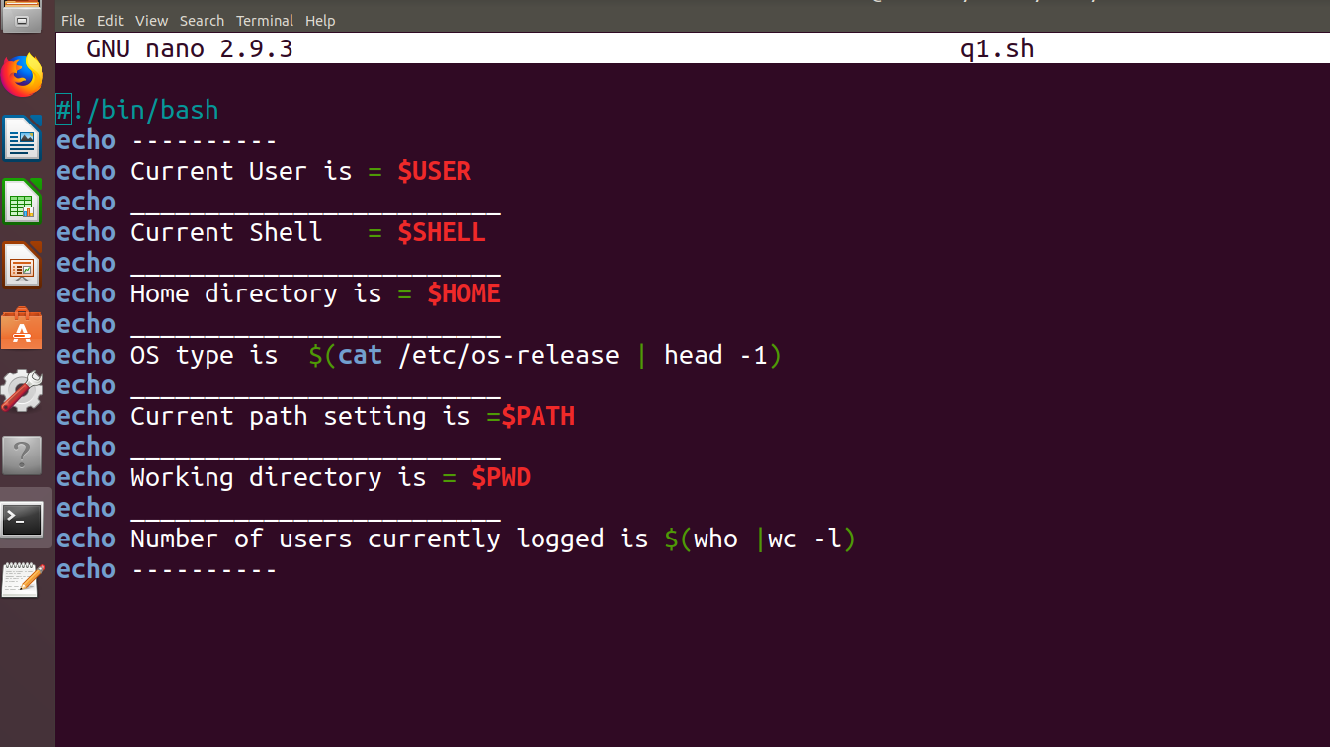
shell script

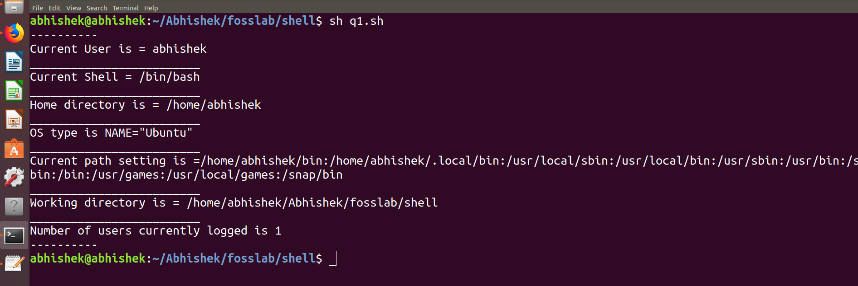
Output

2. Write a shell script to show various system configurations like
1. your OS and version, release number, kernel version
2. all available shells
3. computer CPU information like processor type, speed etc
4. memory information
5. hard disk information like size of hard-disk, cache, model etc
6. File system (Mounted).

Shellscript

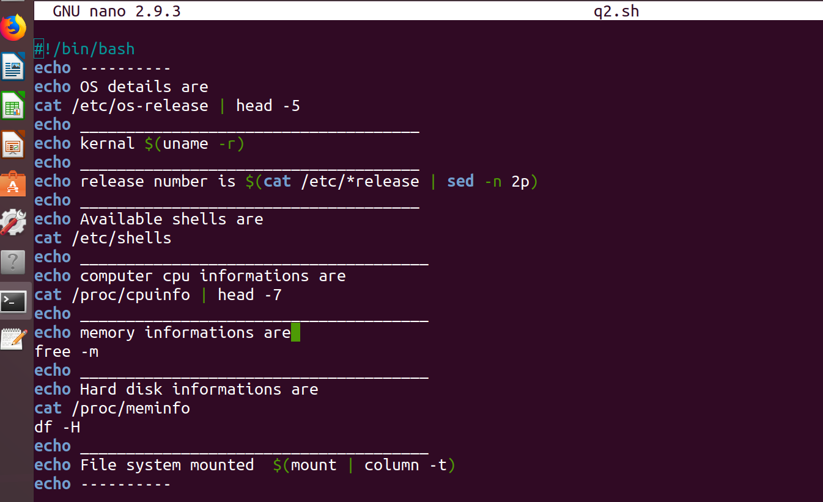

output
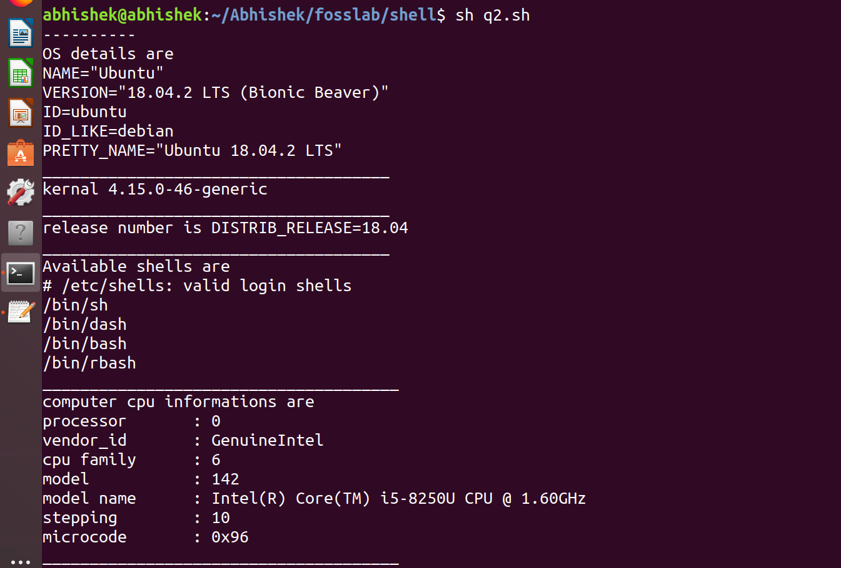
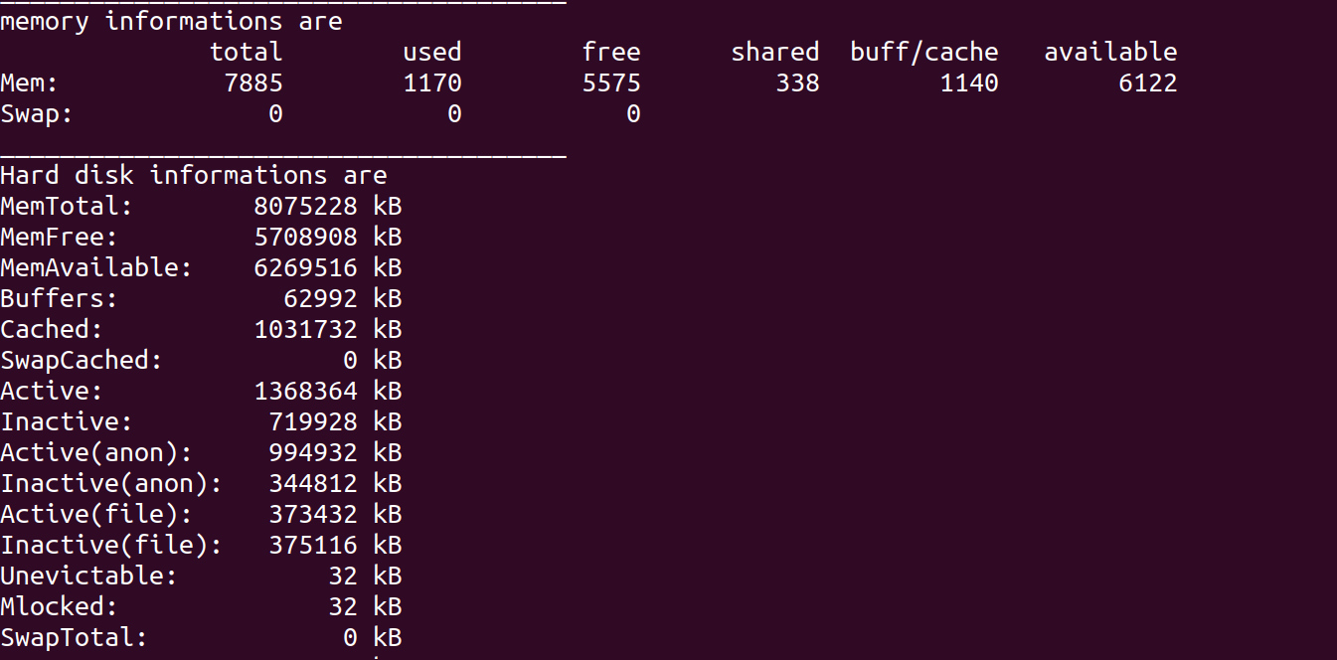
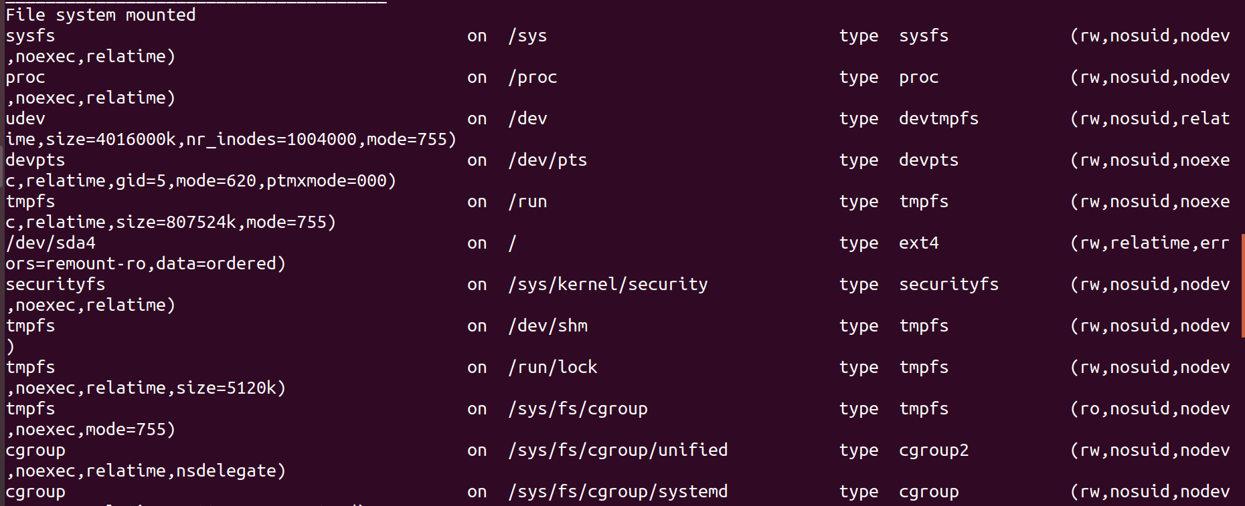
3. Write a shell script to implement a menu driven calculator with following functions
1. Addition
2. Subtraction
3. Multiplication
4. Division
5. Modulus

Shellscript
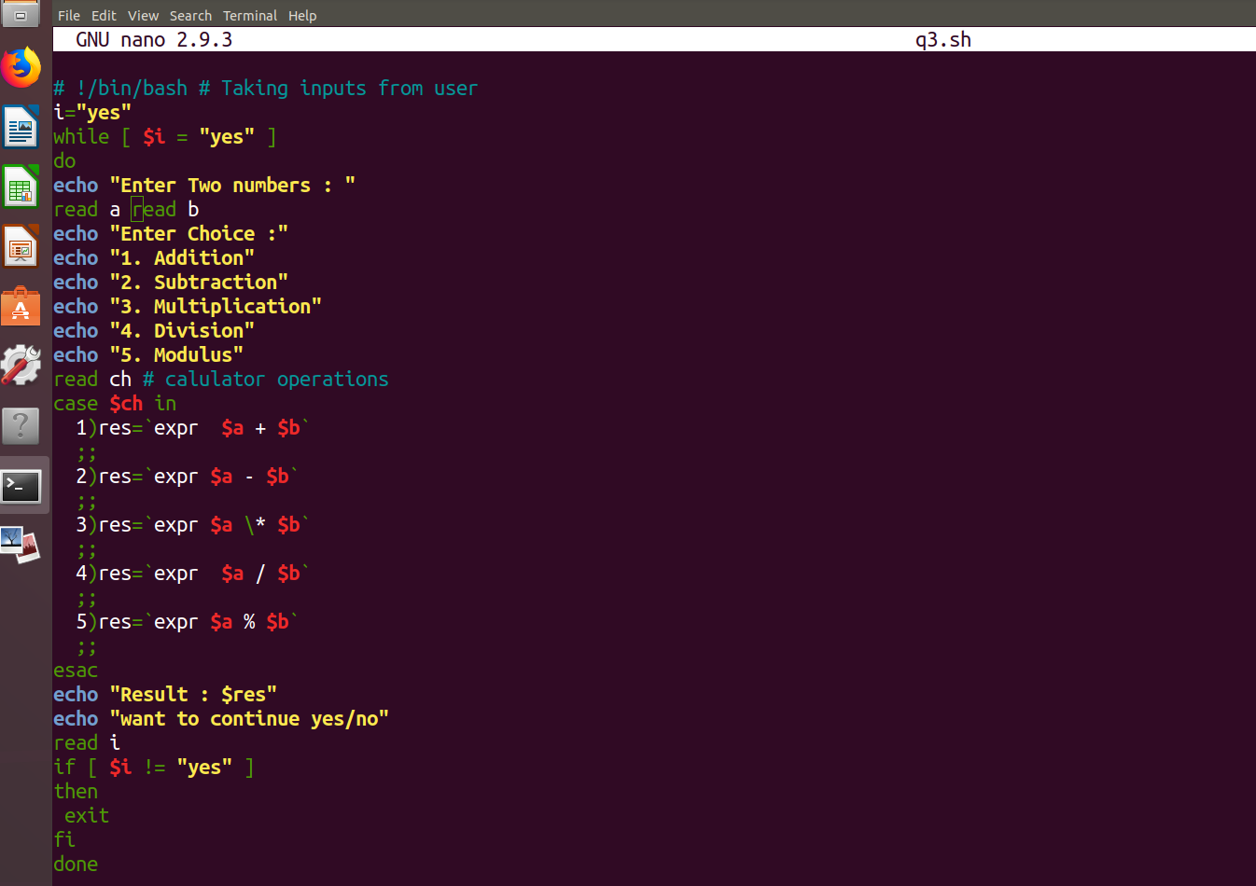

output
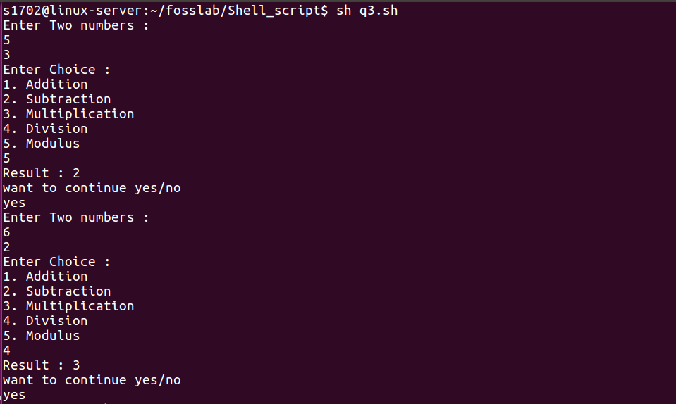

4. Write a script called addnames that is to be called as follows ./addnames ulist username
Here ulist is the name of the file that contains list of user names and username is a particular student&#39;s username. The script should
1. check that the correct number of arguments was received and print a message,in case the number of arguments is incorrect
2. check whether the ulist file exists and print an error message if it does not
3. check whether the username already exists in the file. If the username exists, print a message stating that the name already exists. Otherwise, add the username to the end of the list.

Shellscript
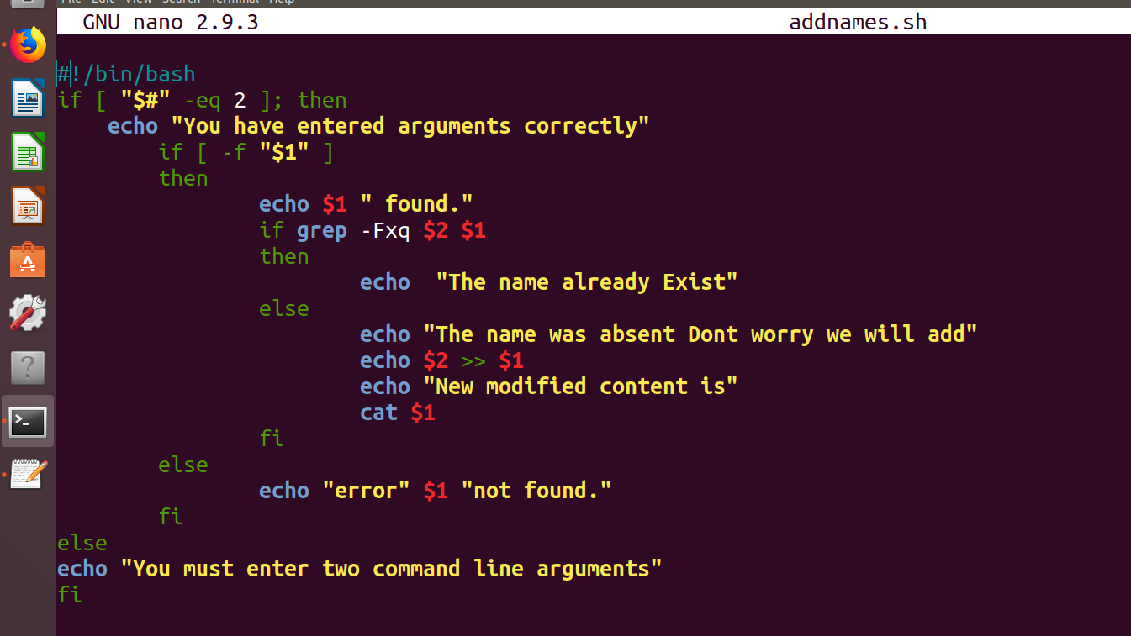
output
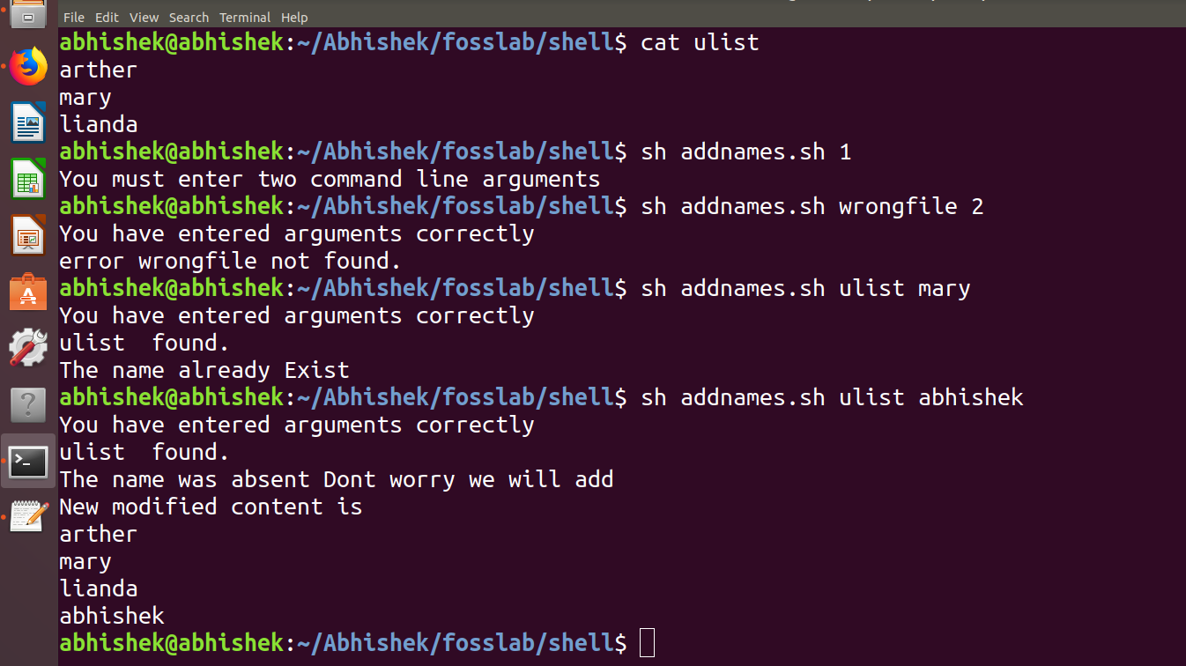
5. Write a Shell script which starts on system boot up and kills every process which
uses more than a specified amount of memory or CPU.

Shellscript
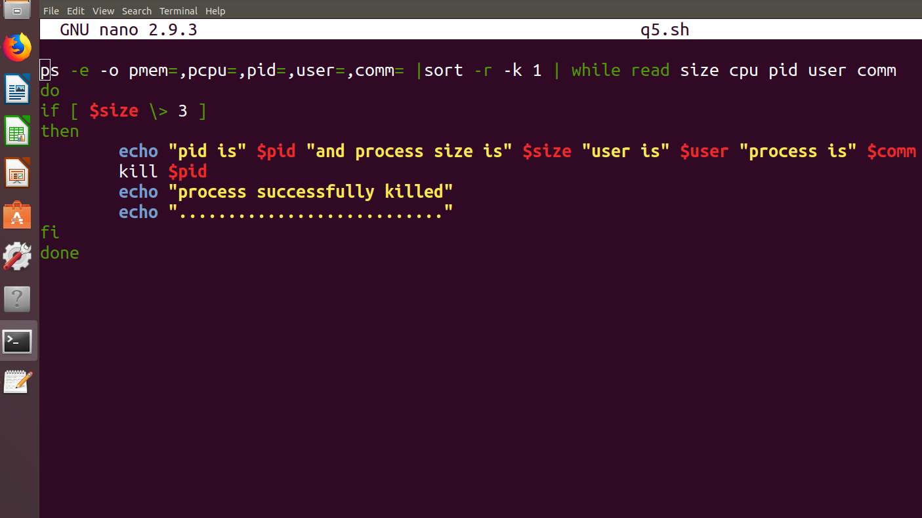
output
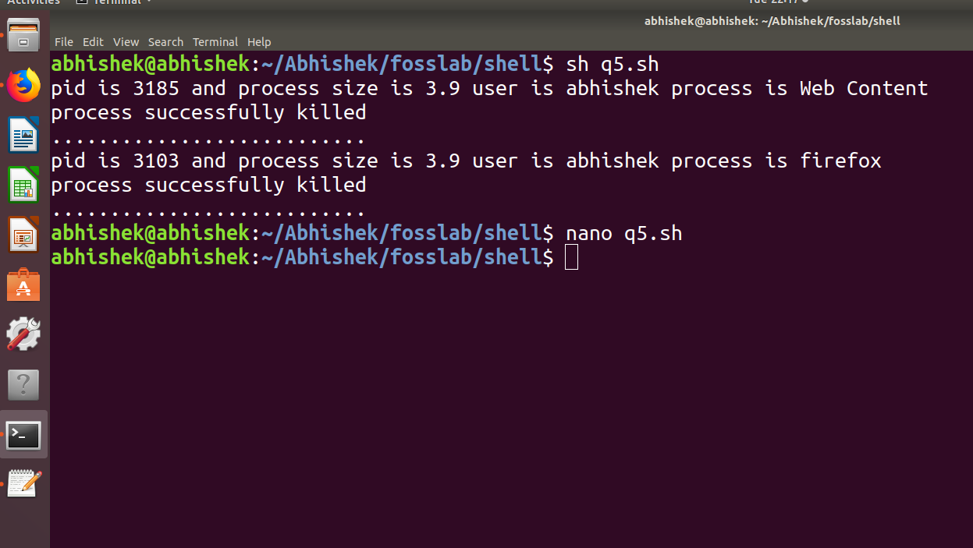
submitted by
Abhishek manoharan No 2

